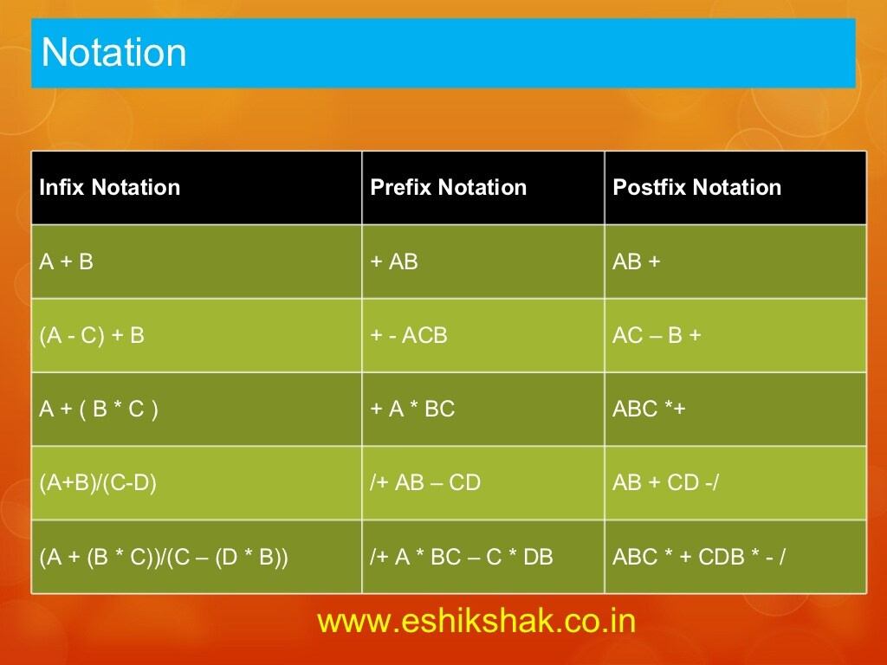

Infix

(A+B)/(C-D)

Reverse

)D-C(/)B+A(

Input stack output

) )

D ) D

- )- D

C )- DC

( DC-

/ / DC-

) /) DC-

B /) DC-B

+ /)+ DC-B

A /)+ DC-BA

( / DC-BA+

/ DC-BA+/

/+BA-CD

X=(A+B)/(C-D)

Input stack output

( (

A ( A

+ (+ A

B (+ AB

) AB+

/ / AB+

( /( AB+

C /( AB+C

- /(- AB+c

D /(- AB+CD

)

AB+CD-

AB+CD-/

a=2

B=4

C=5

D=7

Reverse

X=B+)c-A(

Input stack output

B B

+ + B

) +) B

C BC

_ +)- BC

A BCA

( BCA-

+ BCA-+

Pre fix = +-ACB

Infix

(A-c)+B

X=(A-C)+B

Input Stack output

( (

A ( A

- (- A

C (- AC

) AC-

+ + AC-

B + AC-B

AC-B+